|  |  |
| --- | --- |
| **EGC Upward & Onward Logo** | Student Name _______________________    **Eastern Goldfields College**  Mathematics Essentials 2019  Test 3 - Weighting 8%1 |
| **Working Time: 60 minutes** | **Total Marks: 59 marks** |

**Calculator assumed & 1 A4 page of notes**

**Show all working where necessary to maximize your marks.**

**Question 1 (5 marks)**

State the coordinates of each point.

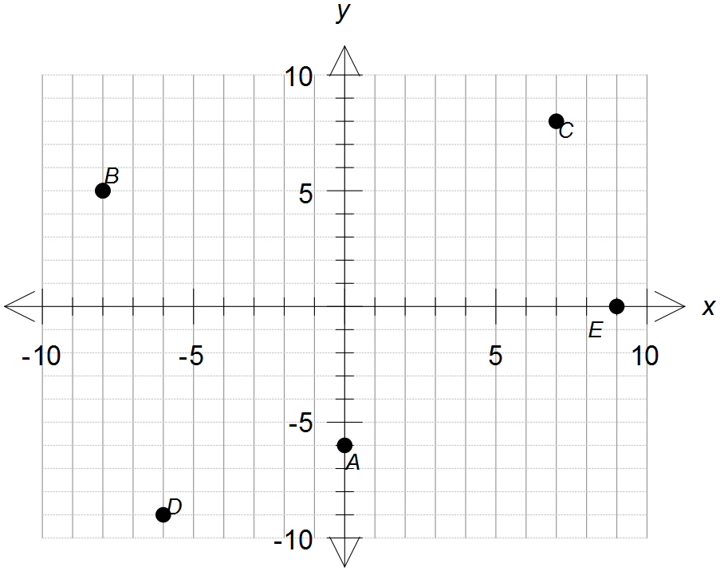

A

B

C

D

E

**Question 2 (6 marks – 2, 2, 2)**

Complete the tables using the rule stated

1. b)

|  |  |  |  |  |  |
| --- | --- | --- | --- | --- | --- |
| **x** | **-1** | **0** | **1** | **2** | **3** |
| **y** |  |  |  |  |  |

|  |  |  |  |  |  |
| --- | --- | --- | --- | --- | --- |
| **x** | **-1** | **0** | **1** | **2** | **3** |
| **y** |  |  |  |  |  |

|  |  |  |  |  |  |
| --- | --- | --- | --- | --- | --- |
| **x** | **-2** | **0** | **1** | **4** | **5** |
| **y** |  |  |  |  |  |

**Question 3 (5 marks - 1, 1, 2, 1)**

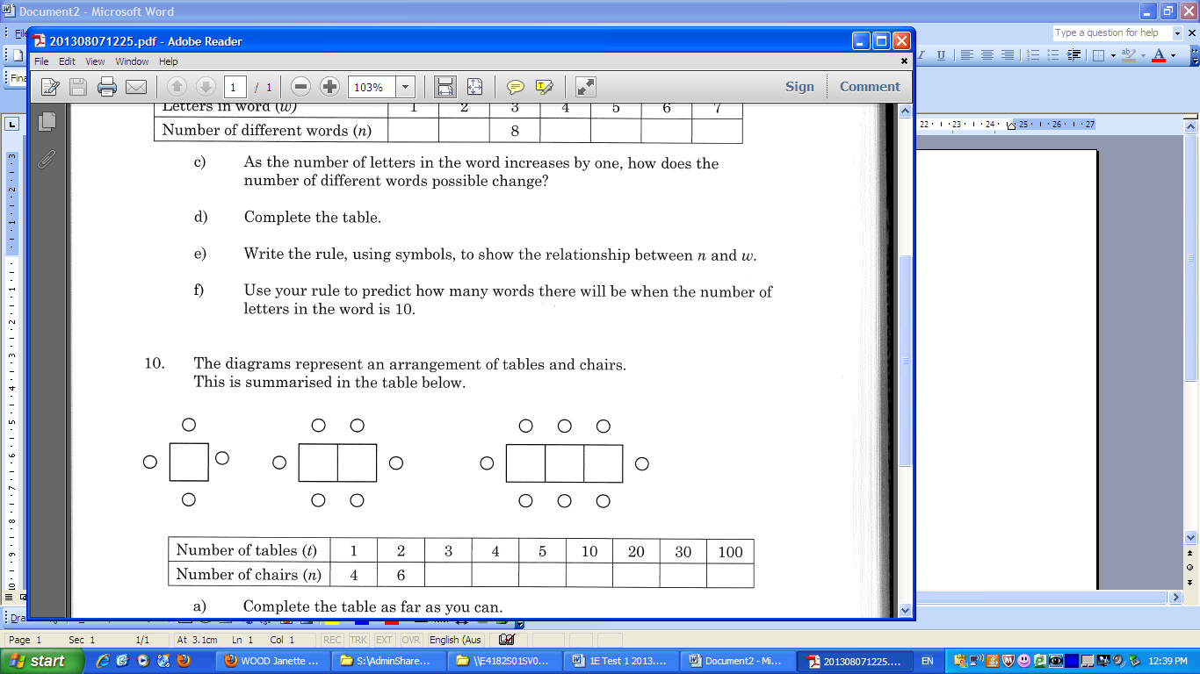The diagrams below represent an arrangement of tables and chairs.

This is summarized in the table below.

1. Draw the next diagram in the pattern. **[1]**
2. Complete the table for values for t = 3 and t = 4. **[1]**

|  |  |  |  |  |  |  |  |  |
| --- | --- | --- | --- | --- | --- | --- | --- | --- |
| Number of tables (t) | 1 | 2 | 3 | 4 | 5 | 10 | 20 | 100 |
| Number of chairs (n) | 4 | 6 |  |  |  |  |  |  |

c) Write a linear relationship linking (t) and (n) **[2]**

d) Complete the table above **[1]**

**Question 4 (6 marks - 3, 3)**

State the rate of change and vertical intercept then write the linear relationship of the line from the following tables:

|  |  |  |  |  |  |
| --- | --- | --- | --- | --- | --- |
| **x** | **-1** | **0** | **1** | **2** | **3** |
| **y** | **10** | **6** | **2** | **-2** | **-6** |

|  |  |  |  |  |  |
| --- | --- | --- | --- | --- | --- |
| **x** | **-1** | **0** | **1** | **2** | **3** |
| **y** | **1** | **2** | **3** | **4** | **5** |

**Rate of change: Rate of change:**

**Vertical intercept: Vertical intercept:**

**Linear Relationship: Linear Relationship:**

**Question 5 (2 marks)**

The following graph shows the motion of a runner on a path.

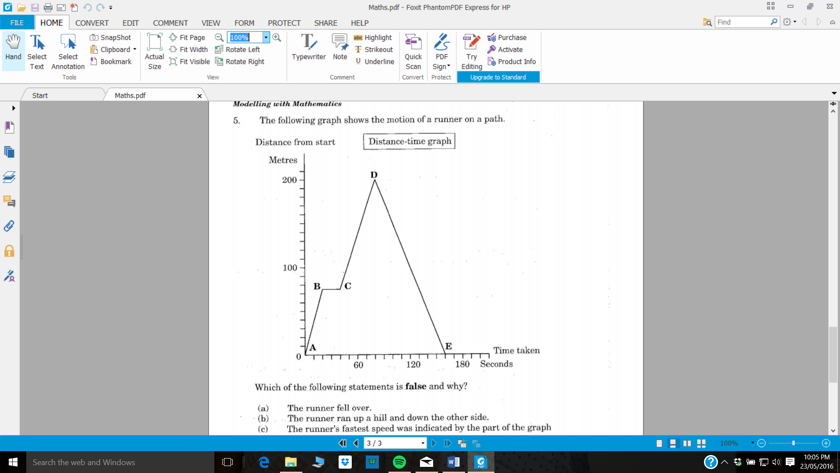

Which of the following statements is **false** and why? **[1]**

1. *The runner fell over.*
2. *The runner ran up a hill and down the other side.*
3. *The runner’s fastest speed was indicated by the part of the graph marked AB.*
4. *The runner’s average speed was the same as the speed indicated by the part of the graph marked DE.*

Reason:__________________________________________________________ **[1]**  
 __________________________________________________________

**Question 6 (7 marks: 2, 3, 2)**

Determine the linear relationship of the following lines on the Cartesian plane below

[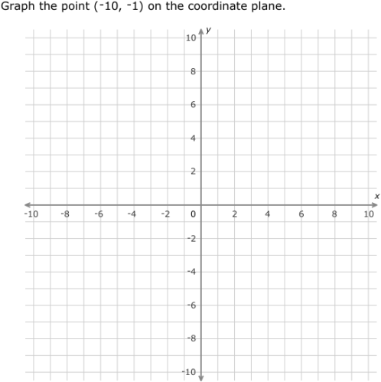](https://www.google.com/url?sa=i&rct=j&q=&esrc=s&source=images&cd=&cad=rja&uact=8&ved=2ahUKEwj7w6GM6LDhAhXPXCsKHZ9dC1AQjRx6BAgBEAU&url=https://au.ixl.com/math/year-7/coordinate-plane-review&psig=AOvVaw1ONUpt9ZbpavdPXcUg6rwe&ust=1554274022012659)

Line 3

Line 1

Line 2

Line 1:

Line 2:

Line 3:

**Question 7 (13 marks - 2, 2, 3, 3, 3)**

The graph below shows the cost, based on the energy used, to transport bottled water from its source to the consumer. Ampac Trucking and Beta Trucking distribute water bottles to shops and charge for this service. Beta company’s cost ($*C*) per km (*d*) is shown on the graph.

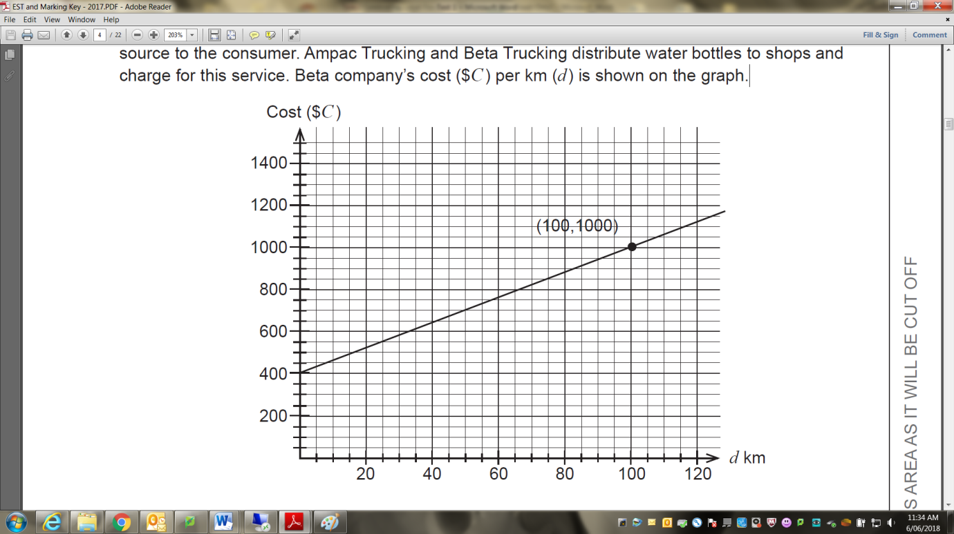

1. For Beta Trucking:
   1. Determine and describe the significance of the vertical intercept. **[2]**

* 1. Determine the rate of change (related to the slope of the line). **[2]**
  2. Determine the linear relationship between cost ($*C*) and km (*d*) travelled. **[3]**

1. Ampac Trucking charge an initial cost of $600 and $3 per km as shown in the table below. Draw a graph of this relationship onto the previous page. **[3]**

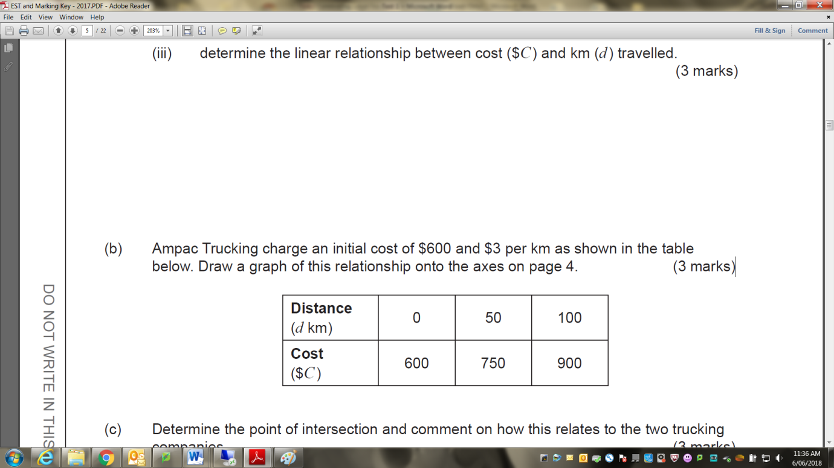

1. Determine the point of intersection and comment on how this relates to the two trucking companies. **[3]**

**Question 8 (9 marks – 2, 3, 2, 2)**

Australians spent more than $500 million on bottled water in 2016. The average cost of a litre of bottled water was $2.83. By comparison, the average cost of a litre of tap water was $0.001.

1. Complete the table of values below.

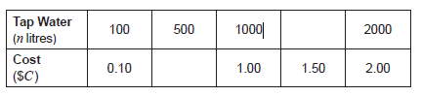

1. Draw the graph of the relationship between the number of litres and the cost of tap water on the axes below.

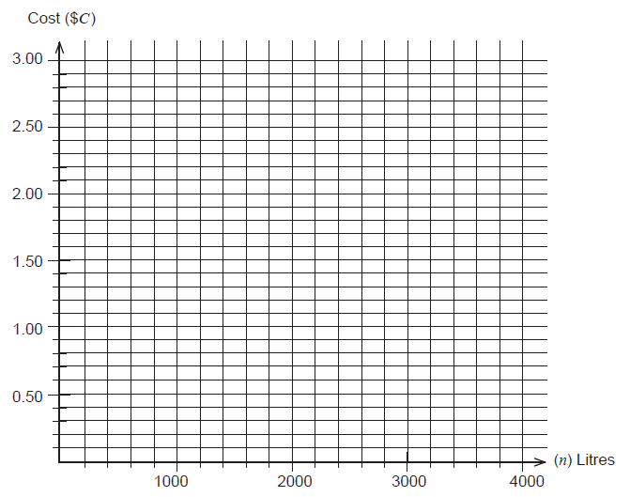

1. Identify the rate of change from the table in part (a) or graph in part (b). Determine the linear relationship between cost ($*C*) of tap water and the number of litres (*n*).
2. Use your graph to determine the amount of tap water that could be purchased for the cost of a litre of bottled water.

**Question 9 (6 marks – 3, 3)**

The additional greenhouse gases emitted by manufacturing are said to be contributing to rising temperatures across the globe. The CO2 levels in the Southern Hemisphere have been recorded in parts per million (ppm) and are shown in the scatterplot below.

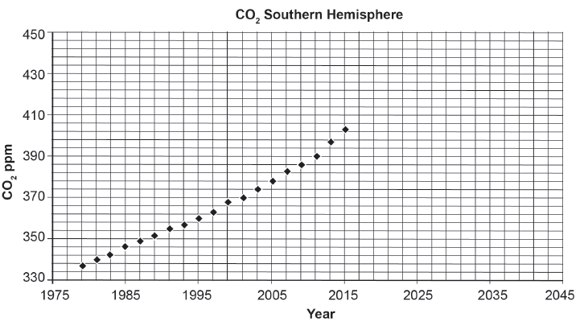

1. A safe level of CO2 in the atmosphere is considered to be 350 ppm. By comparison, 430 ppm is considered extremely dangerous, raising global temperatures by up to 2°C.Use an appropriate method to predict the years when the CO2 levels will reach these levels.
2. Compare the reliability of each of your predictions.

**END OF TEST**